Python has the following data types built-in by default, in these categories:

|  |  |
| --- | --- |
| Text Type: | str |
| Numeric Types: | int, float, complex |
| Sequence Types: | list, tuple, range |
| Mapping Type: | dict |
| Set Types: | set, frozenset |
| Boolean Type: | bool |
| Binary Types: | bytes, bytearray, memoryview |

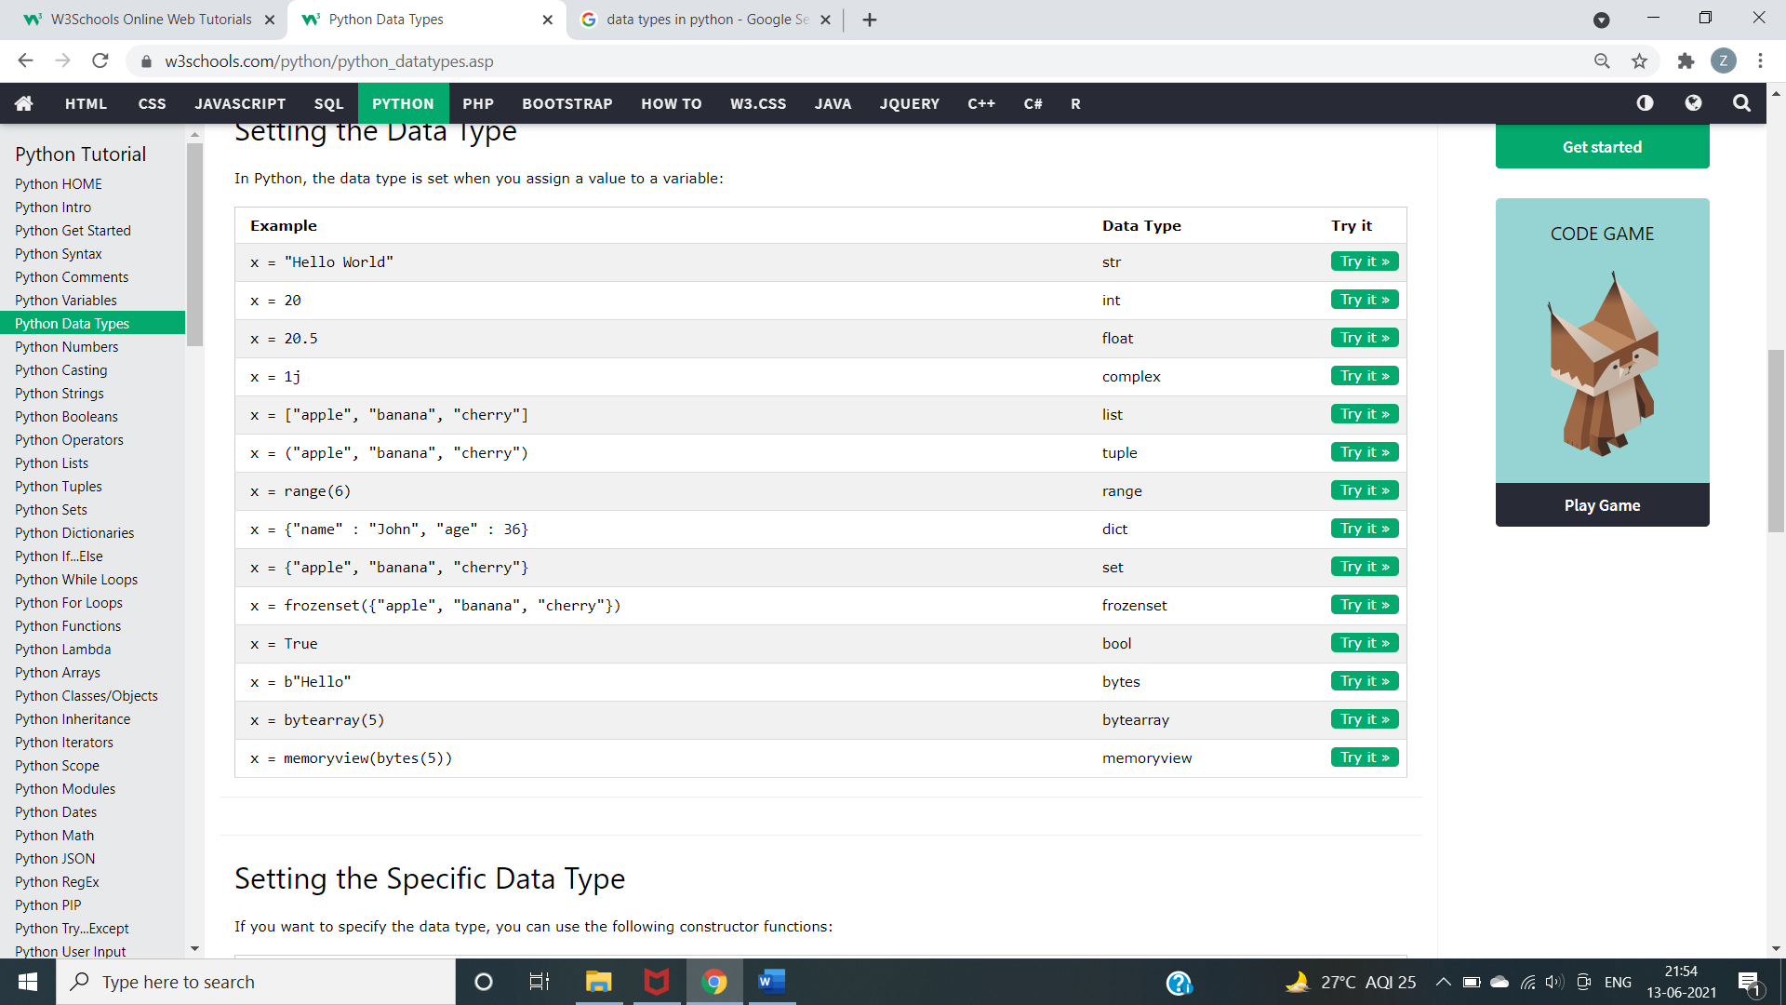

Strings are---slicing, b = "Hello, World!"  
print(b[2:5])

Modify

a = " Hello, World! "  
print(a.strip()) # returns "Hello, World!"added space

a = "Hello, World!"  
print(a.lower())

and concatenate strings

a = "Hello"  
b = "World"  
c = a + b  
print(c)

Format String

age = 36  
txt = "My name is John, and I am {}"  
print(txt.format(age))

Boolean Values

In programming you often need to know if an expression is True or False.

You can evaluate any expression in Python, and get one of two answers, True or False.

### **Example**

print(10 > 9)  
print(10 == 9)  
print(10 < 9)

### **Example**

Evaluate two variables:

x = "Hello"  
y = 15  
  
print(bool(x))  
print(bool(y))

Python divides the operators in the following groups:

* Arithmetic operators
* Assignment operators
* Comparison operators
* Logical operators
* Identity operators
* Membership operators
* Bitwise operators

## List

Lists are used to store multiple items in a single variable.

Lists are created using square brackets:

### **Example**

Create a List:

thislist = ["apple", "banana", "cherry"]  
print(thislist)

Types

## Access Items

List items are indexed and you can access them by referring to the index number:

thislist = ["apple", "banana", "cherry"]  
print(thislist[1])

Negative indexing means start from the end

-1 refers to the last item, -2 refers to the second last item etc.

### **Example**

Print the last item of the list:

thislist = ["apple", "banana", "cherry"]  
print(thislist[-1])

## Tuple

Tuples are used to store multiple items in a single variable.

A tuple is a collection which is ordered and **unchangeable**.

Tuples are written with round brackets.

Tuple items are ordered, unchangeable, and allow duplicate values.

Tuple items are indexed, the first item has index [0], the second item has index [1] etc.

When we say that tuples are ordered, it means that the items have a defined order, and that order will not change.

Tuples are unchangeable, meaning that we cannot change, add or remove items after the tuple has been created.

## Set

Sets are used to store multiple items in a single variable.

A set is a collection which is both unordered and unindexed.

Sets are written with curly brackets.

Set items are unordered, unchangeable, and do not allow duplicate values.

Unordered means that the items in a set do not have a defined order.

Set items can appear in a different order every time you use them, and cannot be referred to by index or key.

Sets are unchangeable, meaning that we cannot change the items after the set has been created. Sets cannot have two items with the same value.

## Dictionary

Dictionaries are used to store data values in key:value pairs.

A dictionary is a collection which is ordered*, changeable and does not allow duplicates.

Dictionaries are written with curly brackets, and have keys and values:

thisdict = {  
  "brand": "Ford",  
  "model": "Mustang",  
  "year": 1964  
}  
print(thisdict["brand"])